# Generated Questions

## Chapter 1

Chapter Visual References:

Image 1:

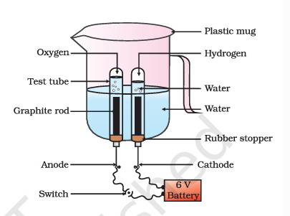

This figure is a diagram of a simple electrolysis cell, which is a device used to produce hydrogen and oxygen gases from water. The cell consists of a plastic mug containing water, a test tube filled with water, a graphite rod, a rubber stopper, and a 6V battery. The graphite rod is connected to the anode, which is the positive terminal of the battery, and the cathode, which is the negative terminal of the battery. When the switch is closed, an electric current flows through the cell, causing water to be electrolyzed into hydrogen and oxygen gases. The hydrogen gas is collected in the test tube, while the oxygen gas is collected in the plastic mug. This figure represents the basic principles of electrolysis and is often used in educational contexts to teach students about the chemical reactions that occur in electrolysis cells.

Image 2:

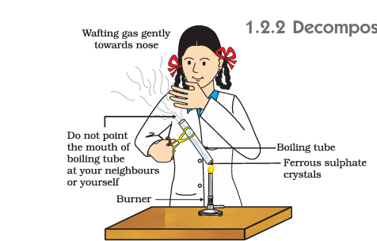

This figure is from a textbook and represents a chemistry experiment demonstrating the decomposition of ferrous sulfate crystals. The figure shows a person wearing a lab coat and holding a boiling tube containing ferrous sulfate crystals. The person is using a burner to heat the boiling tube, causing the crystals to decompose and release a gas. The gas is being wafted gently towards the person's nose, and the person is instructed not to point the mouth of the boiling tube at their neighbors or themselves. This experiment is likely used to teach students about the decomposition of compounds and the release of gases during chemical reactions.

Image 3:

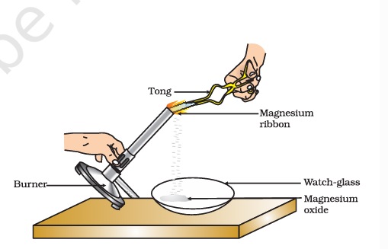

This figure is a diagram from a textbook that illustrates the process of heating magnesium ribbon in a laboratory setting. Here is a detailed description of the figure and its educational context:  
  
1. **Burner**: The burner is a device used to heat the magnesium ribbon. It is typically a Bunsen burner or a similar type of gas burner.  
  
2. **Tong**: The tong is a tool used to hold and manipulate the magnesium ribbon. It is important to use tongs to handle the hot magnesium ribbon safely.  
  
3. **Magnesium Ribbon**: The magnesium ribbon is a thin strip of magnesium metal. It is being heated by the burner.  
  
4. **Watch-glass**: The watch-glass is a small, flat glass dish used to collect the products of the reaction. In this case, it is collecting magnesium oxide.  
  
5. **Magnesium Oxide**: The white powdery substance that collects in the watch-glass is magnesium oxide (MgO). This is the product of the reaction between magnesium and oxygen.  
  
The figure represents the chemical reaction between magnesium and oxygen, which results in the formation of magnesium oxide. This reaction is often used in chemistry to demonstrate the concept of combustion and the formation of oxides. The educational context of this figure is to teach students about chemical reactions, the properties of magnesium, and the use of laboratory equipment. It also serves as a visual aid to help students understand the process and the products of the reaction.

Image 4:

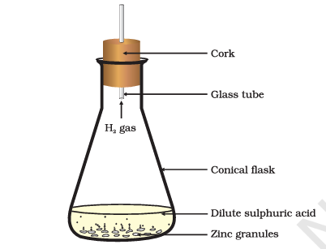

This figure is a diagram of a simple apparatus used to demonstrate the reaction between zinc and dilute sulfuric acid to produce hydrogen gas. The apparatus consists of a conical flask containing dilute sulfuric acid and zinc granules, a glass tube, and a cork with a small hole through which the hydrogen gas is produced. The hydrogen gas is collected in the glass tube and can be observed as bubbles. This experiment is commonly used in chemistry to teach students about the reaction between metals and acids, as well as the properties of hydrogen gas.

### Questions

**MCQs**

1. **MCQ (Image 3):** When magnesium ribbon is heated as shown in Image 3, what is the primary product formed?

(A) Magnesium hydroxide

(B) Magnesium oxide

(C) Magnesium carbonate

(D) Magnesium nitrate

**Answer: B**

2. **MCQ (Text):** Which law governs the balancing of chemical equations?

(A) Law of constant proportion

(B) Law of conservation of mass

(C) Avogadro’s law

(D) Boyle’s law

**Answer: B**

3. **MCQ (Text):** In the reaction Fe + CuSO4 rightarrow FeSO4 + Cu , which type of reaction occurs?

(A) Combination

(B) Decomposition

(C) Displacement

(D) Double displacement

**Answer: C**

•--

**Short Answer Questions**

4. **Short Answer (Image 2, 2 marks):** What safety precaution is emphasized in Image 2 during the decomposition of ferrous sulfate crystals?

**Answer:** The gas released should be wafted gently toward the nose instead of directly inhaled to avoid exposure to toxic fumes.

5. **Short Answer (2 marks):** Why is respiration considered an exothermic reaction?

**Answer:** It releases energy by breaking down glucose molecules, which is used for bodily functions.

6. **Short Answer (2 marks):** Give an example of a combination reaction from daily life.

**Answer:** Burning coal: C + O2 rightarrow CO2 .

7. **Short Answer (2 marks):** Why is paint applied to iron articles?

**Answer:** To prevent contact with moisture and oxygen, thereby reducing rusting (oxidation).

8. **Short Answer (2 marks):** What is the skeletal equation for the formation of water from hydrogen and oxygen?

**Answer:** H2 + O2 rightarrow H2O .

•--

**Long Answer Questions**

9. **Long Answer (Image 1, 5 marks):** Describe the electrolysis process in Image 1. Include the reactions at the anode and cathode.

**Answer:** In the electrolysis cell, water splits into hydrogen and oxygen. At the cathode (negative terminal): 2H2O + 2e^- rightarrow H2 + 2OH^- . At the anode (positive terminal): 4OH^- rightarrow O2 + 2H2O + 4e^- .

10. **Long Answer (5 marks):** Balance the equation Fe + H2O rightarrow Fe3O4 + H2 .

**Answer:** Balanced equation: 3Fe + 4H2O rightarrow Fe3O4 + 4H2 .

11. **Long Answer (5 marks):** Distinguish between displacement and double displacement reactions with examples.

**Answer:** Displacement: One element replaces another (e.g., Zn + CuSO4 rightarrow ZnSO4 + Cu ). Double displacement: Ions exchange (e.g., NaCl + AgNO3 rightarrow AgCl + NaNO3 ).

12. **Long Answer (5 marks):** Explain oxidation and reduction using the reaction ZnO + C rightarrow Zn + CO .

**Answer:** Carbon is oxidized (gains oxygen to form CO), while ZnO is reduced (loses oxygen to form Zn).

13. **Long Answer (5 marks):** Why are decomposition reactions called the opposite of combination reactions? Provide equations.

**Answer:** Combination: 2H2 + O2 rightarrow 2H2O . Decomposition: 2H2O rightarrow 2H2 + O2 .

•--

**Case-Based Questions**

14. **Case-Based (Image 4):** A student sets up the apparatus in Image 4 (zinc + dilute H2SO4 ).

• - What gas is produced? How can it be tested?

• - Write the balanced equation.

**Answer:**

• - Hydrogen gas; it burns with a pop sound.

• - Zn + H2SO4 rightarrow ZnSO4 + H2 .

15. **Case-Based (Text):** An iron nail left in a humid environment develops a reddish-brown coating.

• - Name the chemical process and the product.

• - Suggest two prevention methods.

**Answer:**

• - Rusting (iron oxide, Fe2O3cdotH2O ).

• - Painting or galvanizing.